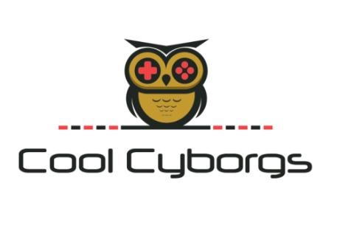

HACKFO

PROCESS DESIGN DOCUMENT





Table of contents

About This Document

1 Overview  
   
 1.1 Objective  
   
 1.2 Tools to be used  
   
 1.3 Packages to be used

2 To Be Business Process Flow  
   
 2.1. Scope

2.2 Flow

3 Workflows  
   
 3.1 Sign In and Log file Creation

3.2 Searching for the event

3.3 Adding event to the calendar

4 Algorithm and Flowchart

4 Deployment Design

5 Developer Details

# About This Document

The Process Design Document describes in detail the business processes chosen for automation and the design approach for the robot being developed using the approved Robotic Process Automation **(RPA) Tool - UiPath** and various online platforms that provide data about events conducted globally.

The document describes the sequence of steps performed as part of the process, and the conditions, rules, and exceptions of the process prior to and after automation. This design document serves as base documentation under the details required for robotic automation of the same business process.

What is meant by RPA?

Robotic process automation (RPA) is **a productivity tool that allows a user to configure one or more scripts (which some vendors refer to as “bots”) to activate specific keystrokes in an automated fashion**. It is converting human work to a digital work.

What is UiPath used for?

UiPath **streamlines processes, uncovers efficiencies and provides insights, making the path to digital transformation fast and cost-effective**. It leverages existing systems to minimize disruption.

Document Revision History

This section records the history of significantchanges to this document. Only the most significant changes are described here. Where significant changes are made to this document, the version number will be incremented by 1.0. Minor changes made for clarity and reading purposes, where no change is made to the meaning or intention of this document, will be indicated by a 0.1 increase in the version number.

# 1 Overview

This HACKFO bot is to assist the faculties, students, and researchers to access information on hackathons or events conducted all over the country and also at the global levels. And prepare well in advance and participate efficiently and successfully. The events include local workshops, seminars, and symposia, conferences that take place within the country as well as globally.

Objectives

To reduce manual work, and increase the efficiency of the work. And useful for all language users.

| End-User | College Students School Students  Faculties  Researchers  Event enthusiasts |
| --- | --- |
| **UiPath Products Used** | 1. Speech  2. UiPath Form  3. Web API  4. Language Translator  5. UiPath Studio |
| **Other – Integrations / APIs / Technologies Used** | 1. WhatsApp API Key  2. Data Scraping  3. Excel Automation  4. SMTP  5. Google Calendar |

## 1.2 UiPath Tools Used

1. Speech

2. UiPath Form

3. Web API

4. Language Translator

5. UiPath Studio  
6. Excel Automation  
7. Data Scraping  
8. SMPT (Mail Activities)

Application:

1. Google calendar

Web apps like

2. unstop

3. Devposts

4.MNH(Major League Hacking)

5.Mettl,

6. Hackathons near me etc..

5. Web WhatsApp

1.3 Packages used

1. UiPath Intelligent OCR

2. Speech

3. UiPath Form

4. Document understanding ML

5. OmniPage

6. Web API

7. Language Translator

# 2 To Be Business Process Flow

## 2.1. Scope

We used UiPath and other free platforms that make our project cost-efficient. And in this documentation, the automation workflow/sequence with the explanation is listed.

At first to provide the Sign in screen we will be using UiPath forms. Once the user login, the bot

begins to run and shows the various tasks which it can perform on the screen. The user needs to select the required activities they need to perform. Those activities includes searching for events

related to their domain that are registered at various platforms like Unstop, Devposts,MNH(Major League Hacking),Mettl, Hckathons near me etc., Where our bot scraps the required data and stores them in an excel form for user analysis. Here the user can analyse the most prioritized events and make the bot run to continue with the further processes like applying for the events and google calendar automations. Here the user only needs to login to websites that are needed for participating., which reduces the wastage of time in the process.

### 2.2 Flow

| **Process Name** | **Activities** |
| --- | --- |
| Sign In | Ask the user to sign in by using their userID and password. |
| Log file creation | Collects every activity and interaction between the user and the bot during the runtime. |
| Language Selection | Users can select the language to communicate /interact with the bot. |
| Select area of interest | Users need to select an area of interest like hackathons or presentations etc,. |
| Searching for the events | The bot searches the event on different websites both the national level and also the global level |
| Storing the data | The bot stores the scraped data of the events and the hackathons in the excel sheet |
| Sending the scraped data | The Bot sends the scraped data to the user's mail and if the user needs to share with connections the bot sends the mail for them too. |
| Analyzing the data | Once the excel is sent to the user’s mail the user needs to check the excel sheet and remove the unwilling events in the sheet |
| Feeding events in the Google calendar | Once the excel sheet is analyzed by the user the bots feed it to the google calendar and set the remainder. |
| Sending messages in WhatsApp | The bot sends the data that has been scraped regarding the events in the user’s WhatsApp number. If the users will send it to their friends the bot does that too. |

# 3 Workflows

**Sign In:**The Sign-In process is a 2-step verification method.  
First, the user needs to enter the password and if the password is valid an OTP will be generated and will be sent to the user’s email id.

**Log File creation:**Folder name: Date_(current_date), File name: Log_(user & min).  
In this log file, every action taken by both user and the bot will be noted with time. In the future, anything HR needs to view back, or any occurrence in the workflow can be viewed in this log file and by this, we can find and clear the error easily. This Log file will be stored

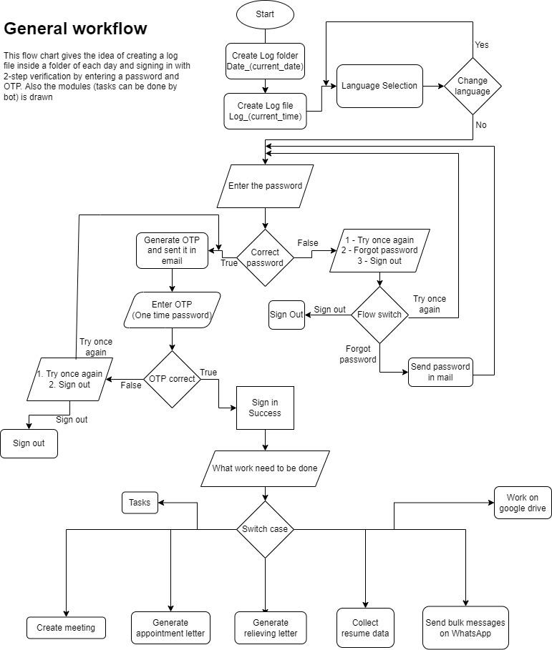

## 4 Deployment Design

Robot will be packaged and deployed in the user's personal system to run the workflow. It can be downloaded in the website This robot should be triggered manually by the authorizer who has access to the bot.

## 5 Developer details

## 5.1 Nithesh M Shrishti id: 221278

## 📱+91 99441 68071

## 📧[nitheshm1705@gmail.com](mailto:nitheshm1705@gmail.com)

## 🔗<https://www.linkedin.com/in/nitheshm/>

## 5.2 Nishanth Subramanian E Shrishti id: 221280

## 

## 📱+91 9345936252

## 📧[nishanth03subramanian@gmail.com](mailto:nishanth03subramanian@gmail.com)

## 🔗<https://www.linkedin.com/in/nishanth-subramanian-232a6622a/>

## 5.3 Mithilesh R Shrishti id: 221280

## 

## 📱+91 94898 78182

## 📧[mrmithil03@gmail.com](mailto:mrmithil03@gmail.com)

## 🔗<https://www.linkedin.com/in/mithil-r-b95b4b24a/>